Administrator can’t access in Azure Stack. Need to have customer service and give handshake for a time (session).

AWS has free trial

Code School

#### Line up Form Elements Responsively with Bootstrap

<div class="row">

<form action="/submit-cat-photo">

<div class="row">

<div class="col-xs-6">

<label><input type="radio" name="indoor-outdoor"> Indoor</label>

</div>

<div class="col-xs-6">

<label><input type="radio" name="indoor-outdoor"> Outdoor</label>

</div>

</div>

<div class="row">

<div class="col-xs-4">

<label><input type="checkbox" name="personality"> Loving</label>

</div>

<div class="col-xs-4">

<label><input type="checkbox" name="personality"> Lazy</label>

</div>

<div class="col-xs-4">

<label><input type="checkbox" name="personality"> Crazy</label>

</div>

</div>

<div class="col-xs-7">

<input type="text" class="form-control" placeholder="cat photo URL" required>

</div>

<div class="col-xs-5">

<button type="submit" class="btn btn-primary"><i class="fa fa-paper-plane"></i> Submit</button>

</div>

</form>

</div>



#### Create a Bootstrap Headline

<h3 class="text-primary text-center">jQuery Playground</h3>

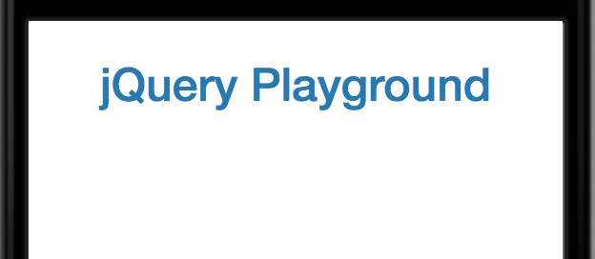

#### Create a Bootstrap Row

<div class="container-fluid">

<h3 class="text-primary text-center">jQuery Playground</h3>

<div class="row">

</div>

</div>

Split your Bootstrap Row

<div class="row">

<div class="col-xs-6">

</div>

<div class="col-xs-6">

</div>

</div>

#### Create Bootstrap Wells

Bootstrap has a class called well that can create a visual sense of depth for your columns.

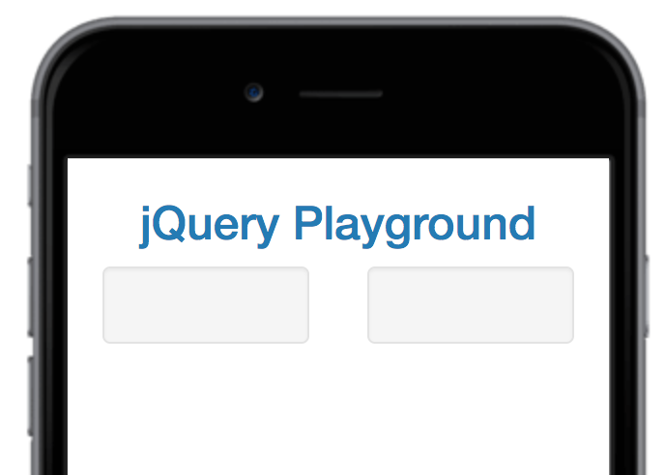

#### Add Elements within your Bootstrap Wells

#### <div class="col-xs-6">

#### <div class="well">

#### <button>

#### </button>

#### <button>

#### </button>

#### <button>

#### </button>

#### </div>

#### </div>

#### <div class="col-xs-6">

#### <div class="well">

#### <button>

#### </button>

#### <button>

#### </button>

#### <button>

#### </button>

#### </div>

#### </div>

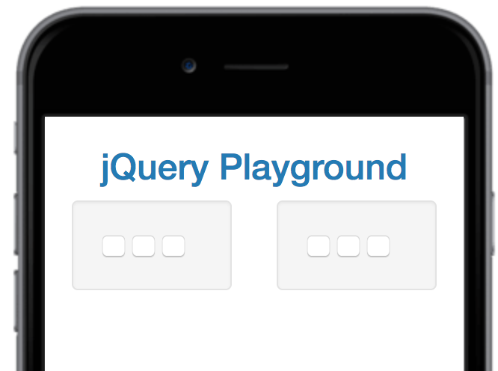

#### Apply the Default Bootstrap Button Style

<div class="well">

<button class="btn btn-default"></button>

<button class="btn btn-default"></button>

<button class="btn btn-default"></button>

</div>

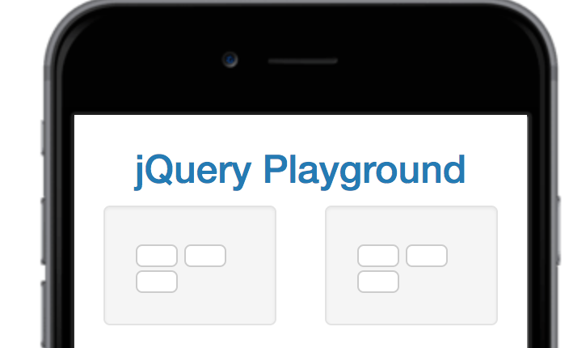

#### Create a Class to Target with jQuery Selectors

<div class="well">

<button class="btn btn-default target"></button>

<button class="btn btn-default target"></button>

<button class="btn btn-default target"></button>

</div>

#### Add ID Attributes to Bootstrap Elements

<div class="well" id="left-well">

<button class="btn btn-default target"></button>

<button class="btn btn-default target"></button>

<button class="btn btn-default target"></button>

</div>

</div>

<div class="col-xs-6">

<div class="well" id="right-well">

<button class="btn btn-default target"></button>

<button class="btn btn-default target"></button>

<button class="btn btn-default target"></button>

</div>

</div>

Label Bootstrap Wells

<div class="container-fluid">

<h3 class="text-primary text-center">jQuery Playground</h3>

<div class="row">

<div class="col-xs-6">

<h4>

#left-well

<div class="well" id="left-well">

<button class="btn btn-default target"></button>

<button class="btn btn-default target"></button>

<button class="btn btn-default target"></button>

</div>

</h4>

</div>

<div class="col-xs-6">

<h4>

#right-well

<div class="well" id="right-well">

<button class="btn btn-default target"></button>

<button class="btn btn-default target"></button>

<button class="btn btn-default target"></button>

</div>

</h4>

</div>

</div>

</div>

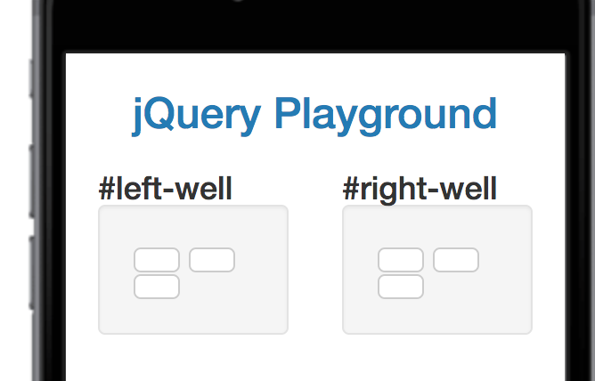

#### Give Each Element a Unique ID

<button class="btn btn-default target" id="target1"></button>

<button class="btn btn-default target" id="target2"></button>

<button class="btn btn-default target" id="target3"></button>

Label Bootstrap Buttons

<button class="btn btn-default target" id="target2">#target2</button>

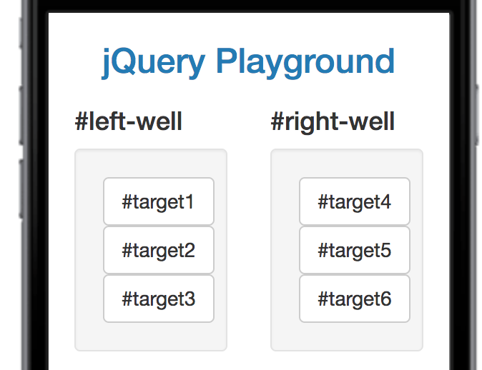

#### Use Comments to Clarify Code

<!--Only change code above this line-->

#### Learn how Script Tags and Document Ready Work

<script>

$(document).ready(function() {});

</script>

#### Target HTML Elements with Selectors Using jQuery

<script>

$(document).ready(function() {

$("button").addClass("animated bounce");

});

</script>

**Resource: MDN Developer**

https://developer.mozilla.org/en-US/